Kevin Geraghty, Chairman  Michael Chizy, Vice Chairman  Ryan Fattman, Clerk  John L. Hebert  Michael Frustaci  James A. Smith, Town Administrator | 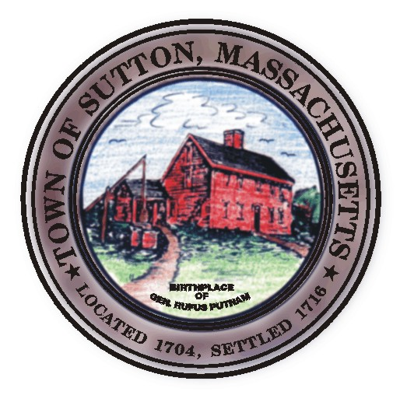 | Sutton Town Hall  4 Uxbridge Road  Sutton, Massachusetts 01590  (508) 865-8727  Fax: (508) 865-8721
Town Of Sutton
Board Of Selectmen

Meeting Agenda

7:00 p.m. – Tuesday, April 22, 2008

Sutton Town Hall, Selectmen’s Meeting Room

- Call to Order, Pledge of Allegiance at 7:00 p.m.

- Public Forum: Limited to 5 minutes per topic. Discussion or comments about town employees or agency members shall be avoided so as not to violate individual’s rights.

- Minutes
  - Board of Selectman minutes from 04/08/08
Executive Session minutes from 04/08/08
Proclamations
2. Arbor Day Proclamation scheduled for May 2nd, 2008
Little League Parade scheduled for May 4th, 2008

- Sponsored Agenda and Action Items
3. Capital Stabilization Authorization
4. Budget Transfers to cover deficits for FY08
5 Approve and sign Town Meeting Warrant
6. Sign Annual Town Election Warrant
- Reverse 911 Memorandum of Understanding

- Old Business
B&C Automotive + Sales, Inc. Signing of Class II license (motion made at 4/08/08 meeting/Bond received)

- Town Administrator Update
- Announcements
- Selectman’s Roundtable: Correspondence and Business Topics
- Executive Session

Adjournment

